Contents
1. Introduction 2
2. Related Work 3
3. Data collection and Description 4
3.1 Primary Data 7
3.2 Secondary Data 8
4. Research Approach and Methodologies 11
4.1 Onion Model 11
4.2 Research Methodology 21
5 Results and Discussion 22
6 Conclusion and Recommendations 40
7 Reflections 44
References 51

Report Title
Mohammad Kanaan and Islam Alomari
¹ Al Hussein Technical University, Amman 11831, Jordan
22110343@htu.edu.jo, Islam.Alomari@htu.edu.jo

Abstract
This research project presents the development of a context-based movie recommendation system that utilizes user-generated tags from the MovieLens dataset. The goal is to improve the personalization and relevance of movie suggestions by analyzing semantic patterns within these tags. The study applies TF-IDF vectorization and cosine similarity to identify meaningful relationships between movies based on how users describe them, focusing on emotional tone, genre, and thematic context. A user survey was conducted to validate the importance of mood and personalization in movie selection, with results indicating strong demand for smarter, mood-aware systems. The model was implemented using Python and evaluated for efficiency, explainability, and potential scalability. Findings confirm that tag-based semantic similarity offers a lightweight, explainable approach to context-aware recommendations and highlight opportunities for future enhancements including mood detection, hybrid filtering, and deep learning integration.

Keywords: Context-aware Recommendation, TF-IDF, MovieLens Dataset, Cosine Similarity, Movie Recommendation System

Introduction
Different approaches and technologies to program machines to behave like learning, reasoning, and decision-making human beings are known as artificial intelligence. The heart of AI includes those algorithms and statistical models with the help of which machines can perform tasks that have always required a human mind. At first, AI made possible more and more complicated performances such as recognizing video images, understanding the spoken word, reasoning while making decisions, and working with real-time analytics. Currently, the entire world has been transformed and places such as healthcare, finance, entertainment, education, and transport have been affected by how they operate; therefore, the changes are being profoundly brought down lines of industry and increasing operational efficiencies around the globe.
Clearly, since the beginning, the path from rule-based logic systems to today's advanced deep learning networks represents a dramatic change in AI systems. From narrowly defined applications with strict requirements, and constraints of rigidity, AI burgeoned with advances in computational capabilities and large datasets. Modern AI systems work on machine learning and deep learning to facilitate an adaptive form of learning, in which there is no explicit programming for each specific task. Such mechanisms allow the building of models that can detect complex relationships, predict outcomes from these relationships, and improve their own performance over time on the basis of that experience. Hence, it is clear that AI has now become a precursor of new innovations that have empowered personalized applications—applications that optimize processes and mine knowledge from vast and complex datasets.
In the entertainment domain, especially in recommendations of movies, AI is a key enabler in keeping the user engaged and satisfied. Recommendation systems apply machine learning and natural language processing to analyze user behavior, preferences, and situational contexts. In particular, context-based recommendation systems tend to emphasize user history and some other factors that are always in more of a flux: such as mood, genre preferences, time of viewing, and type of social environment. Context-aware models utilize a dataset with rich user-generated tags and ratings, such as the MovieLens dataset, to generate recommendations quite relevant to particular users for highly personalized movie suggestions. These developments create a revolution in the way users discover content, resulting in improved engagement and greater satisfaction.
The main question this research project is trying to answer is: "How to use context-aware information to improve the accuracy and relevance of movie recommendations?" The major objective of the study is to design and evaluate a context-based movie recommendation system on the basis of the MovieLens tags dataset. The system aims to provide recommendations more compatible with the user's situational preferences by studying user-tags that indicate moods, genres, and themes. The primary contribution of this work is the demonstration of the efficiency of contextual cues integrated within content-based filtering models for personalized movie recommendation systems. Furthermore, this project enhances the understanding of Natural Language Processing (NLP) for utilizing data (tags) to capture subtle user preferences instead of traditional rating-based systems.
The organized format of this document is as follows: In section 2, related work, previous works or methodologies on context-aware and content-based recommendation systems have been reviewed. Section 3 describes data collection and description, elaborating on the MovieLens tags dataset and data preparation. Proposed approach is introduced in section 4, which deals with context modeling techniques and employed recommendation algorithms. Experiments and results are presented and analyzed in section 5 by means of various evaluation metrics to show performance on the system. Finally, in section 6, conclusions are drawn, followed by suggestions and recommendations for the future work and research areas.

Related Work
Research on movie recommendation systems has grown substantially over the past decade, particularly with the integration of context-aware models that improve recommendation accuracy and personalization. In this section, we summarize three key research papers relevant to the development of context-based recommendation systems, focusing on their methodologies, main findings, and limitations.

Paper 1: Context-Aware Recommender Systems
Adomavicius, G., & Tuzhilin, A.

This primary document was contextual-theory on Context-Aware Recommender Systems (CARS), urging the inclusion of context in the recommendation by time, location, mood, and company. There were three veins of how context-integration can be done such as pre-filtering, post-filtering, or contextual modeling. Pre-filtering uses contextual data to filter the training data before modeling, post-filtering applies context after recommendation generation, and contextual modeling integrates the different contexts into the prediction algorithm. From the study, it was found that when using contextual information, the recommendation is said to be greatly improved in relevance. The study was basically found as a theoretical proposition without applications to the mentioned techniques in any datasets, thus having a gap in empirical validations in a wide range, such as movie recommendations.

Paper 2: Context-Aware Movie Recommendations: An Empirical Comparison of Pre-filtering, Post-filtering and Contextual Modeling Approaches
Campos, P. G., Fernández-Tobías, I., Cantador, I., & Díez, F.

Way back, this empirical work examined three context-aware recommendation methods—pre-filtering, post-filtering, and contextual modeling—using the data set from MovieLens. The researchers had incorporated contextual dimensions of mood, time, and location into the recommendation task. Their experiments showed that contextual modeling produced accurate results when compared to the two other methods, although this came at the expense of computational complexity and sensitivity towards data sparsity. One main strength of this study was the empirical application of theoretical concepts across a real-world dataset. On the other hand, one main limitation was the narrow range of contextual variables considered, limiting, perhaps, the generalizability of the results to other even richer datasets.

Paper 3: An Optimal Context-Aware Content-Based Movie Recommender System Using Genetic Algorithm: A Case Study on MovieLens Dataset

A recommendation model is proposed for recommending movies based on contents and optimized recommendations on the best contextual features from the MovieLens dataset through Genetic Algorithm (GA). First, it extracted movie features (genres, tags) and user behavior data to implement GA search through the most relevant combinations of extracted features to make recommendation precision better. Results of the experiments show that it increases the precision of recommendations according to context and content-based filtering over standard techniques. However, still, the main drawback of this study is its very innovative optimization approach to find recommendation logic using such computer-intensive processes, such as GA, which stand in the way of real-time recommendations in giant systems.

Data collection and Description
- Primary data
Primary data are raw information collected first-hand by the researcher or generated directly through user interaction for a specific use. It thus represents raw and unprocessed information that has been derived from original sources, some commonly used being surveys, interviews, focus groups, direct observation, experiments, and digital user activity logs. Because primary data are collected with a specific research purpose in mind, they are highly relevant, specific, and tailored to the problem at hand,In AI and machine learning projects, primary data can be user interactions, sensor readings, or logs generated by the system. These are original, real-time glimpses into behaviors, preferences, or feedback, which allow researchers to draw out patterns and build systems that accurately reflect actual user needs and experiences,For this project, the tags.csv file from the MovieLens dataset is a prime example of primary data. Each row represents a user-generated tag, a free-text label assigned to a movie by the user. These tags are personal, spontaneous, and often reflective of the mood, genre perception, themes, or viewing context. For example, a user tagging a movie as "feel-good," "mind-bending," or "family movie" is expressing a contextual opinion at the moment of interaction. This behavior constitutes direct and unfiltered data, thus ideal for building a context-aware recommendation system that adapts to subtle user preferences.
Collection Methods:
Surveys and Questionnaires: Directly asking participants questions designed to respond to the research needs.
Interviews: Interacting with the participant in conversations that are more in-depth, in one-on-one settings.
Observations: Gathering information through the observation of subjects either in a natural or controlled setting.
Primary data offers significant advantages:
- It is highly relevant to the research goal.
- It enables the development of user-centric, personalized systems.
- It allows researchers to explore qualitative context that cannot be extracted from structured metadata alone.
However, it also presents challenges:
- It may require intensive preprocessing, especially when it comes from free-text inputs like tags.
- It is often noisy or sparse, particularly if not all users contribute equally.

- Secondary data
Secondly, data works as data collected by someone else for reasons other than the current research project. The data already has been collected and processed, adding sometimes published, so that it can be used for a different purpose. The researchers make use of secondary data to develop insights or reach new conclusions without going through another expensive, time-consuming data collection phase. In fact, the type varied: large public databases, governmental records, previously done surveys and published findings in academic journals, Secondary data form a basis on which the researcher draws expansion of the studies, especially when the primary data collection is impractical or unnecessary. Say, for example, the researcher analyzing economic trends over time may rely on secondary data from government economic reports instead of conducting direct economic surveys, The availability of secondary data may prove useful in speeding up the research process, allowing researchers to spend their time on data analysis and interpretation rather than data collection, While secondary data could be an invaluable resource, the researcher must always ensure that the data being used is relevant, accurate, and timely to the particular research question in hand. In doing this, the original purpose for which the data was collected can greatly affect how useful and valid it will be within a setting of new research.
Collection methods
The surveys and questionnaires directly asked the participants to answer questions formulated to meet the requirements of the investigation.
Interviews involve interacting with the participant through conversations that are more in-depth and one-on-one in nature.
Observations involve gathering information through the observation of subjects in either natural or controlled contexts.
Experiments are organized in such a way that manipulation of variances are tested for real effects and are thus monitored for good impact.
Ethnographic research applies to entering the culture or environment of the subjects who are being studied.
Secondary data is advantageous in many ways:
- It is readily available and cost-effective.
- It often comes in clean, well-organized formats.
- It allows for benchmarking and comparative studies using common datasets.
However, it also comes with limitations:
- It may lack relevance to the current research focus.
- It cannot capture real-time sentiment or user intent.
- It may contain biases or outdated information not aligned with present contexts.
Feature | Primary Data | Secondary Data
Source | Collected first-hand from users | Pre-collected and published by another source
Relevance | Directly aligned with the research objectives | May require filtering or adaptation to fit the project
Authenticity | Highly authentic and personalized | Structured and standardized
Flexibility | Can be adapted during collection | Fixed and not modifiable at the source
Effort & Cost | Requires more effort to collect (in general) | Easier and cheaper to acquire

3.1 Primary Data
Description of Primary Data
The primary data for this research was collected through an online survey. The survey aimed to understand people’s opinions and behavior when it comes to movie recommendations. It focused on what types of movies users prefer, how often they watch, and how much they rely on AI-based suggestions from platforms like Netflix and Shahid.
The survey contained 15 questions. It included multiple-choice questions, checkboxes, yes/no, and one open-ended question. It was shared on my social media accounts to reach a wide range of people. In total, I received 62 responses. The data collected helps us to understand users' preferences and the problems they face with current recommendation systems. This will support the development of a more useful AI movie recommender.
Experience in Collecting Data
I created the survey using Google Forms and shared it on platforms like WhatsApp and Instagram. Since most people today use smartphones and social media, it was easy for them to access and complete the form. Most responses were submitted quickly in the first few days.
Challenges I Faced:
- Getting people to respond: Some people ignored the form or forgot to fill it out, so I had to repost it and remind others.
- Data quality: A few responses had missing or unclear answers. I had to go through the data and clean it before using it.
- Mixed audience: Not everyone answered the same way. Some misunderstood certain questions, especially the open-ended one.
- Technical issues: A couple of users reported that the form didn't load properly on their phones. I fixed this by simplifying the form layout.
Why I Chose a Survey
- It was fast and easy to collect a lot of answers in a short time.
- It helped me reach many different types of people (students, workers, etc.).
- It worked well with my project because recommendation systems are used by everyday people, not just technical users.
- It allowed me to ask specific questions that relate directly to AI and movie recommendation features.
Benefits of Primary Data
- First-hand info: I got real answers from real people about how they use recommendation systems.
- Tailored to my topic: The questions were made specifically to support my AI model idea.
- Up-to-date and relevant: The data reflects current opinions and habits from users who use movie platforms today.
Limitations of Primary Data
- Sample bias: Since it was shared on my own accounts, most responses came from people similar to me in age and background.
- Short answers: Some answers, especially the open question, weren’t very detailed.
- Not global: My sample doesn't fully represent people from different countries or cultures.
- Time and effort: Even though it was online, it still took time to follow up and clean the results.

3.2 Secondary Data
For this project, the dataset used is tags.csv from the publicly available MovieLens dataset. Although it is considered the primary input for modeling, academically speaking, this file qualifies as secondary data because it was not collected firsthand by the researcher but rather made available by a third party, an institutional body-usually referred to as GroupLens Research. It comprises data produced by real users on the MovieLens platform who would tag a movie with short descriptive labels such as "funny," "dark," or "based on a true story.""

Description of the Secondary Data Used

Column | Description
userId | Unique identifier for the user who assigned the tag
movieId | Identifier for the movie being tagged
tag | The text-based label the user assigned (e.g., “classic”)
timestamp | Unix time at which the tag was created

These tags are rich in contextual meaning and represent how users perceive a movie’s tone, theme, mood, or experience. For example, a tag like “underrated” implies personal opinion, while “family-friendly” implies viewing context. This makes the dataset uniquely suitable for building a context-aware recommendation system.

Justification for Using This Dataset as Secondary Data

Although the dataset consists of user-generated content (which may seem like primary data), it is secondary in nature for this project because:

- It was not collected directly by the researcher.

- It was obtained from an external, pre-existing dataset repository (MovieLens).

- It is used in its original form, without influencing the tagging process.

This makes it ideal for research that requires real-world, behavior-based contextual information without needing to design a survey or manual tagging experiment from scratch.
Merits of the tags.csv Dataset

- Rich in user context: Tags express personal and emotional reactions to movies, such as mood, tone, or social setting.

- High volume and diversity: With over 1 million tags, the dataset offers a wide variety of perspectives and tagging styles.

- Authentic user behavior: Tags are generated naturally during movie consumption, reflecting genuine user experiences.

- No need for manual data collection: Saves significant time and effort while maintaining relevance to the research objective

Limitations of the Dataset

- No control over tag quality: Since tags were not collected under controlled research conditions, they may be inconsistent or ambiguous.

- No explicit context fields: Information such as user mood, location, or device is not recorded separately — it must be inferred from the tag text.

- Language variability: Users use different wording for similar meanings (e.g., “funny,” “hilarious”), which requires preprocessing and normalization.

Papers:

For this project, I used some research papers that talk about how to make better movie recommendation systems using AI. These papers are important because they helped me understand how to build a system that doesn't just look at ratings or genres — but uses context, like mood, themes, or user tags, to make smarter suggestions.

Here’s what the papers were mainly about:

- How to Use Context in Recommendations

One paper explained that a good system should look at things like your mood, the time of day, or even who you’re watching with. This makes the movie recommendations more accurate and personal.

- Comparing Different Methods

Another paper tested different ways of using context (before, after, and inside the recommendation process). It found that putting the context inside the model gives the best results.

- Making the System Even Smarter

The third paper used something called a genetic algorithm to improve how the system picks the best tags for each movie. It showed how even more advanced tools can make the recommendations more helpful.

All of these papers were about using data and smart techniques to make better, more human like recommendations which is exactly what I wanted to do in my project.

Justification:

I used these research papers because:

- They’re trusted: These are from smart people and universities, and they’ve been checked by others (peer-reviewed).

- They match my topic: Every paper talks about context-aware or tag-based movie recommendation systems, just like my project.

- They saved time: I didn’t have to figure out everything from scratch. The papers gave me a great start.

- They gave me new ideas: Like using cosine similarity or TF-IDF to match movies based on how they “feel.”

- They helped me check my work: I could see if my system made sense by comparing it to what other researchers did.

Merits of Secondary Data:

- The papers explain how systems are built, what works best, and why.

- The models in the papers were tested using data, so the results are reliable.

- Each paper has its own approach, so I got to learn about a few different ways to solve the same problem.

Limits of Secondary Data:

- They’re sometimes too general: The papers talk about recommendation systems in general, but not always about the exact data I used.

- Some are a bit old: AI changes fast. Some of the ideas are still great, but might not include the newest tech.

- Not always easy to apply I had to be careful when using ideas from the papers, because they might have been tested in different situations.

Research Approach and Methodologies
State what is included in this section in one paragraph.
This section outlines the philosophical foundation, research approach, methodological choice, strategy, and tools used to develop the context-based movie recommendation system. It begins by identifying the research philosophy, positivism, followed by a deductive reasoning approach to test the hypothesis using real-world data. A mixed-method methodology was adopted, combining quantitative data from the MovieLens tags dataset with qualitative feedback from a user survey. The research strategy integrates both archival analysis and a cross-sectional survey, ensuring a balance between technical implementation and user-centric design. Finally, the section describes the techniques and procedures for data cleaning, vectorization using TF-IDF, similarity analysis via cosine distance, and implementation in Python, providing a clear justification for each decision based on the project’s goals and constraints.

Onion Model
Describe the onion model.
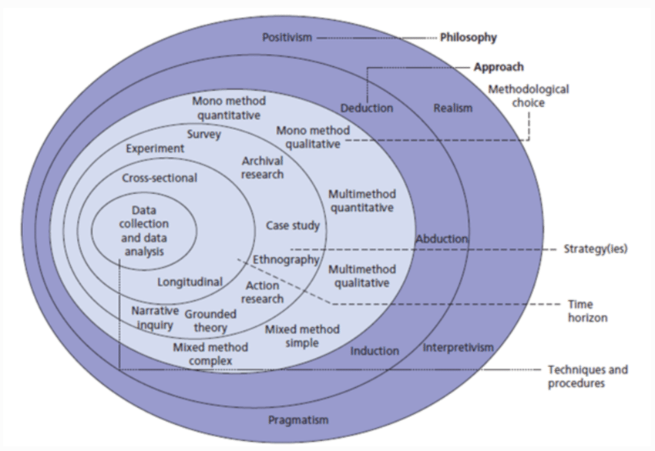
Figure 1: The structure of the Onion Research Model [1].
1. Research Philosophy:
This is the outer layer of the onion and refers to the way a researcher views the world and gains knowledge. Positivism is about using facts and numbers to study reality. Interpretivism focuses on understanding people’s behavior and meanings. Realism believes there is a real world, but we all see it differently. Pragmatism is more flexible it uses whatever method works best for the research.

2. Research Approach:
This layer shows how the researcher connects theory and data. Deduction means starting with a theory and testing it using data. Induction means collecting data first and then developing a theory. Abduction is a mix of both looks at data and tries to find the best possible explanation.

3. Methodological Choice:
Here, the researcher chooses between using one method or combining different ones. A mono method uses only one type (either qualitative or quantitative). A multi-method uses more than one tool from the same type. A mixed method uses both qualitative and quantitative methods together to get deeper results.
4. Research Strategy:
The strategy is the plan for how the research will be done. Examples include surveys, case studies, experiments, or ethnography. Each one has its purpose like surveys for collecting a lot of data or case studies for deep understanding of a single case.
5. Time Horizon:
This explains the time period of the study. A cross-sectional study collects data at one point in time. A longitudinal study collects data over a longer time to track changes or progress.
6. Techniques and Procedures:
This is the center of the onion and focuses on the actual tools used to collect and analyze data. These include methods like interviews, questionnaires, or data analysis software. The tools must fit the strategy and approach chosen earlier.

    - Philosophy
Types of Philosophy:

Positivism:
Positivism is the belief that true knowledge comes only from observable, measurable facts. It assumes that researchers can objectively collect and analyze data to discover truths about the world. This philosophy is commonly used in quantitative studies, where hypotheses are tested using statistical methods. In research that involves structured data and looks for patterns or predictions—like a recommendation system—positivism is highly suitable.

Interpretivism:
Interpretivism sees reality as something shaped by human experiences and meanings. It focuses on understanding how people think, feel, and behave in certain situations. Unlike positivism, it uses qualitative data such as interviews or personal feedback. While interpretivism is useful for exploring deep insights into user experiences, it is less focused on generalizing results or building data-driven systems.

Realism:
Realism accepts that there is a real world, but also understands that our knowledge of it is influenced by personal interpretation. It mixes both positivist and interpretivist ideas and allows for both qualitative and quantitative data. Realism is good when a study needs to combine different views, but it can be complex to manage in strictly structured research like AI system development.

Pragmatism:
Pragmatism is a flexible philosophy that focuses on what works best in a given situation. It supports using any method—qualitative, quantitative, or mixed—that helps solve the research problem. Pragmatists care more about useful results than about sticking to one specific theory. This is helpful for practical systems like recommender engines where both technical performance and user feedback matter.

Chosen Philosophy and Justification:

Research Philosophy Overview:
For this project, positivism was selected as the most appropriate philosophy. The study focuses on analyzing a real dataset (MovieLens tags.csv) and numerical survey responses to develop a recommendation system. Positivism supports the use of structured methods and statistical tools to test and improve AI performance, making it the best fit for a project that relies on data patterns, tagging behavior, and measurable outcomes.

Characteristics of Positivism:

Empirical Evidence: This project relies on real-world movie tags and survey answers, which are both observable and quantifiable. The AI system uses this data to identify patterns in user preferences and movie content.

Objectivity: The research avoids personal opinions and emotional interpretations. It focuses on analyzing tags and survey data in a neutral, data-driven way to find useful results.

Hypothesis Testing: The recommendation model is evaluated to test whether content-based filtering using tags can improve user satisfaction. This aligns with positivist methods of testing and validating predictions using actual data.

Justification for Choosing Positivism:

Use of Quantitative Data: The dataset and survey both provide numerical, factual information. This allows the research to apply statistical analysis and build a model that can be tested and repeated.

Model Prediction and Evaluation: The AI system is built to predict similar movies based on tags. This goal of prediction and improvement fits well with the positivist focus on measurable success and testing hypotheses.

Replicability: Positivist research is structured and transparent, allowing other researchers to replicate the system using the same dataset and methods. This is important in AI development, where future improvements depend on consistent evaluation.

Application in This Study:
The study applies positivism by using a systematic approach: cleaning and preparing the MovieLens tag data, applying TF-IDF and cosine similarity, and testing how well the system can suggest contextually similar movies. The model is built and tested using Python in Google Colab, and results are interpreted using measurable outputs. Survey data helps evaluate how well recommendations match user expectations. This approach provides strong evidence for improving AI-powered recommendation systems in a way that is reliable and easy to test again in future work.

    - Theory Development Approach

Types of Research Approaches:

Deductive Approach:
The deductive approach begins with a general theory or hypothesis and then tests it using data. It moves from broad concepts to specific observations. In this approach, researchers start with a known theory and design experiments or models to confirm or reject that theory. It is most common in quantitative research and works well when you want to validate an idea or relationship using existing knowledge and structured data.

Inductive Approach:
Inductive reasoning works in the opposite direction. It starts with observations or data collection and then builds a theory based on the patterns found. This approach is usually used in qualitative research where the goal is to explore new ideas and develop understanding from detailed information. It is not focused on proving something but rather discovering insights from the data.

Abductive Approach:
Abductive reasoning is a mix of both deductive and inductive logic. It starts with an observation or surprising result and then looks for the best possible explanation. This method allows flexibility to go back and forth between theory and data. It is commonly used in complex studies that need both exploration and testing.

Chosen Approach and Justification:
Chosen Approach: Deductive
For this project, the deductive approach was selected as the most suitable method. The study begins with the idea that content-based recommendation systems using tags can improve the accuracy and personalization of movie suggestions. This concept is drawn from existing literature and models used by platforms like Netflix. Based on this, the research tests whether a context-aware recommendation engine, built using TF-IDF and cosine similarity on tagged data, can provide relevant and useful suggestions.

Justification for Using Deductive Approach:

Theory-Driven Design: The model is based on prior knowledge of recommendation systems and natural language processing, making it a good fit for hypothesis testing.

Use of Structured Data: The MovieLens tags.csv dataset is clean, structured, and numeric in nature, allowing for direct testing and analysis.

Clear Evaluation Criteria: The effectiveness of the system can be evaluated using metrics like similarity scores, which align with the deductive model's need for clear evidence.

Focus on Testing Outcomes: The purpose of the research is to test whether using tags improves recommendation quality not to build a new theory from scratch.

Application in This Study:
The project applies the deductive approach by starting with a clear research question and building a recommendation system to test it. The hypothesis is that content-based filtering using user-generated tags can deliver more relevant movie recommendations. The system is implemented in Python using libraries like Scikit-learn, and its performance is analyzed using outputs such as top 10 similarity results. This approach confirms or rejects the hypothesis using real-world data, supporting a structured and focused research outcome.

    - Methodological Choice

Types of Methodological Choices:

Mono Method:
The mono method involves using a single research method—either quantitative or qualitative. It keeps the research process simple and focused but may limit the depth or variety of insights. A mono method is ideal for studies with a narrow scope or when the researcher wants to stick to one type of data, such as numbers or only interviews.

Multi-Method:
Multi-method research uses more than one data collection method, but within the same category. For example, two different types of qualitative tools (like focus groups and interviews) or two quantitative tools (like surveys and experiments). This allows a bit more flexibility while still staying within a single methodological style.

Mixed Method:
The mixed method approach combines both quantitative and qualitative methods in one study. It allows researchers to use both numerical data and detailed, descriptive insights. This method is useful when a topic needs both measurable results and a deeper understanding of human behavior. It supports a broader, more realistic view of the research problem.

Chosen Methodological Choice and Justification:

Chosen Method: Mixed Method
For this research, a mixed-method approach was chosen. The project combines quantitative data from the MovieLens dataset with qualitative insights from user survey responses. This combination helps create a well-rounded recommendation system that is both data-driven and aligned with real user preferences.

Justification for Using Mixed Method:

Data Variety: The study includes structured tag data (quantitative) and opinion-based survey answers (qualitative), both of which are necessary to understand how people experience and evaluate movie recommendations.

Balanced View: The mixed method allows the AI model to be built on hard data while also responding to human feedback, making the system smarter and more user-friendly.

Stronger Analysis: Using both types of data supports deeper analysis. For example, patterns in the dataset can be explained or supported by what people said in the survey.

Real-World Relevance: Real recommendation systems are not just based on numbers—they also consider mood, preferences, and behavior. This method captures that complexity.

Application in This Study:
The research uses tag frequency and cosine similarity techniques (quantitative) to build a recommendation engine, while survey feedback (qualitative) helps evaluate the system and identify improvements. This mixed approach ensures that the system is not only technically accurate but also practical and user centered. It supports the development of a more intelligent, flexible, and explainable recommendation system for movies.

    - Research Strategy

Types of Research Strategies:

Experiment:
An experiment is a strategy where variables are controlled and tested to examine cause-and-effect relationships. It’s mostly used in scientific or technical research. While experiments provide high control and measurable outcomes, they may not reflect real-world conditions.

Survey:
A survey involves collecting data from a large group of people using structured questions. It is ideal for gathering opinions, behaviors, or preferences. Surveys are commonly used in social sciences and business research to analyze user needs, satisfaction, or habits.

Case Study:
A case study is an in-depth investigation of a single subject, group, or situation. It allows for detailed insights and is often used in qualitative research. However, results may not always be generalizable to larger populations.

Action Research:
Action research is practical and involves the researcher actively participating in solving a problem within a specific setting. It is commonly used in education or organizational development.

Ethnography:
This strategy is used to study people and cultures in their natural environment, usually through observation and interaction. It is common in anthropology and social research.

Grounded Theory:
This strategy involves building new theories from data collected during the research. It’s mostly used in qualitative research where no clear theory exists beforehand.

Archival Research:
This involves using existing records, documents, or datasets to answer a research question. It is cost-effective and time-saving, especially when access to real-time data collection is limited.

Chosen Strategy and Justification:

Chosen Strategy: Survey and Archival Research
In this study, a combination of survey and archival research strategies was selected. The survey was used to collect primary data from users about their habits, preferences, and opinions related to movie recommendations. At the same time, archival research was applied by analyzing the MovieLens tags.csv dataset—a well-known, pre-existing dataset containing user-generated tags for thousands of movies.

Justification for Using Survey and Archival Research:

Survey for User Feedback: The survey helped gather direct feedback from potential users. Their responses gave insight into what features they want, how they feel about current systems, and what improvements they expect. This supports the personalization goals of the AI model.

Archival Data for AI Model: The MovieLens tags dataset offers a large amount of structured, labeled data that is perfect for building and testing a content-based recommendation system. It is reliable, clean, and publicly available, which supports the development of accurate AI predictions.

Practicality and Efficiency: Combining these two strategies allowed the project to save time, reduce costs, and still access meaningful data for both the user experience and model training.

Application in This Study:
The research used survey data to understand user preferences and build design requirements for the recommendation system. Simultaneously, archival data (MovieLens tags) was used to train the AI model using techniques like TF-IDF vectorization and cosine similarity. This strategy supports a data-rich and user-aware development process, balancing technical performance with human-centered design.

    - Time Horizons

Types of Time Horizons:

Cross-Sectional Study:
A cross-sectional study collects data at a single point in time. It is often used when the goal is to analyze current conditions, behaviors, or opinions. This type of study is time-efficient and practical for projects with limited duration. However, it does not show how things change over time.

Longitudinal Study:
A longitudinal study involves collecting data over an extended period—days, months, or even years. It is used to observe trends, behavior changes, or long-term effects. While it provides deeper insights, it requires more time, planning, and resources.

Chosen Time Horizon and Justification:

Chosen Time Horizon: Cross-Sectional
This project uses a cross-sectional time horizon. Both the survey and the analysis of the MovieLens tags dataset were conducted and completed during a specific research period. The focus was on understanding user preferences and behavior at one point in time to support the design of the recommendation system.

Justification for Using Cross-Sectional Time Horizon:

Time Efficiency: The project was conducted within a limited academic timeframe, making a cross-sectional design more realistic and manageable.

Snapshot of User Behavior: The goal was to gather current insights into how people interact with movie recommendation systems and what improvements they want. This type of data is best captured through a cross-sectional approach.

Sufficient for Model Building: Since the MovieLens dataset already includes historical tagging information, a new longitudinal study was not necessary. The system could still learn from patterns in the existing data without needing ongoing data collection.

Application in This Study:
Survey responses were collected once through social media platforms, and the MovieLens tags.csv dataset was analyzed as a fixed dataset. This one-time collection was enough to identify user expectations, train the AI model, and test its recommendation accuracy. The cross-sectional time horizon helped complete the study efficiently while meeting the research goals.

    - Techniques and Procedures

Types of Techniques and Procedures:
Data Collection Techniques:
These include methods used to gather raw information. Common techniques are surveys, interviews, observations, and using secondary datasets. Each technique is chosen based on the research aim and the type of data required—quantitative, qualitative, or both.

Data Processing and Cleaning:
This step involves preparing the collected data for analysis. It includes removing missing values, correcting inconsistencies, and formatting the data properly. Clean data is essential to ensure the accuracy and reliability of the results.

Data Analysis Techniques:
This includes the tools and methods used to explore and interpret the data. For quantitative data, it may involve statistical tests, graphs, or machine learning techniques. For qualitative data, it may include thematic analysis, coding, or pattern recognition.

Implementation Tools:
Software tools like Python, Excel, SPSS, or R are commonly used to apply data analysis techniques. In AI or machine learning projects, libraries such as Scikit-learn, Pandas, and Numpy are used for model building and data manipulation.

Chosen Techniques and Justification:
Chosen Techniques:

This project used two main techniques:

1.Online Survey (for primary data collection)

2.Analysis of the MovieLens tags.csv dataset (as secondary data)

For implementation, the AI model was built using Python in Google Colab, utilizing libraries such as:

- Pandas for data manipulation

- TfidfVectorizer from Scikit-learn for text processing

- Cosine Similarity for computing similarity between tags

- Matplotlib/Seaborn for visualizations

Justification for Chosen Techniques and Procedures:

Survey Use: The online survey was simple to distribute and collect, providing user-based feedback on movie-watching habits and recommendation expectations.

Dataset Analysis: The MovieLens tags.csv dataset was already clean and structured, allowing the AI model to be trained effectively using real tagging behavior from users.

Python Tools: Python and its libraries offer powerful and flexible tools for natural language processing and recommendation system development. They are also widely accepted in academic and industry research.

Relevance to AI Modeling: TF-IDF and cosine similarity techniques were chosen because they allow the system to find movies with similar tag contexts—supporting the project’s goal of creating a context-based recommender.

Application in This Study:

- The survey was created using Google Forms and shared on social media for broad response collection.

- Data from the MovieLens tags.csv file was imported into Google Colab, where it was cleaned and processed.

- A content-based AI recommendation model was then built by converting tag text into numerical vectors using TF-IDF and comparing them using cosine similarity.

- The system allowed users to input a movie ID and receive a list of similar movies based on tag similarity, making it both practical and interpretable.

Research Methodology
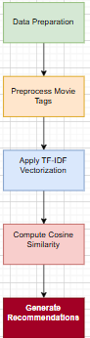
1. Data Preparation
Definition:
This step involves loading the dataset (e.g., tags.csv) and cleaning it by removing rows with missing values in the tag column. It also includes selecting the top 1000 most frequently tagged movies to reduce memory usage.
Justification:
Preparing the data is critical to ensure that the recommendation engine works with clean and relevant information. Filtering the top 1000 tagged movies allows the system to focus on popular and information-rich entries, improving accuracy while optimizing performance.
2. Preprocess Movie Tags
Definition:
Movie tags are grouped by movieId, and all tags associated with the same movie are joined into a single string. This step condenses multiple rows per movie into one, creating a consolidated textual representation for each film.
Justification:
Preprocessing tags ensures that the semantic meaning of all relevant descriptors is captured for each movie. Combining tags makes it possible to analyze the entire context of a movie, which is essential for text-based vectorization and similarity comparison.
3. Apply TF-IDF Vectorization
Definition:
TF-IDF (Term Frequency–Inverse Document Frequency) converts the preprocessed movie tag texts into numerical vectors. Words that are unique or meaningful across the dataset are given more weight.
Justification:
Using TF-IDF allows the system to quantify the importance of each word in a movie's tag set. This technique is effective in emphasizing distinctive features while downplaying common or generic terms, leading to more accurate semantic comparisons.
4. Compute Cosine Similarity
Definition:
Cosine similarity is calculated between all pairs of TF-IDF vectors to assess how similar two movies are based on their tags. A higher cosine score means greater similarity.
Justification:
Cosine similarity is a reliable method for comparing the angle between two vectors, making it ideal for text data. It allows the system to identify movies with similar themes, tones, or categories, even if they don’t share exact words.
5. Generate Recommendations
Definition:
For a given movie, the system finds the most similar ones based on the cosine similarity scores and displays them in a ranked table with their tags and similarity values.
Justification:
This step transforms the similarity analysis into practical output for users. It offers interpretable and transparent suggestions, showcasing how content-based filtering can be used to recommend movies that align with a viewer’s interest or mood based on contextual tags.

Results and Discussion
- Key Data Points from the survey:
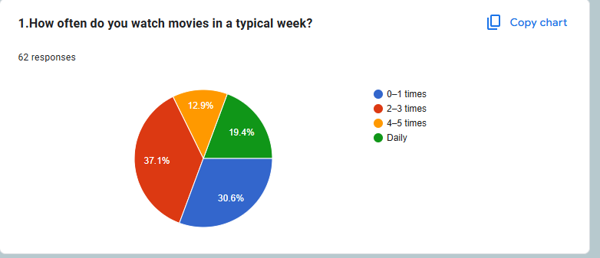
This chart shows that most participants (37.1%) watch movies 2–3 times a week, followed by 30.6% who watch 0–1 times per week. A smaller group watches movies daily (19.4%), and the least (12.9%) watch 4–5 times. This tells us that while movie-watching is a regular activity for many people, it isn’t something they do every single day. From my point of view, this means users don’t have much time to waste browsing, so a good recommendation system should help them quickly find something they’ll enjoy. The system needs to be efficient and smart in suggesting relevant movies, especially for those who watch movies only a few times a week.

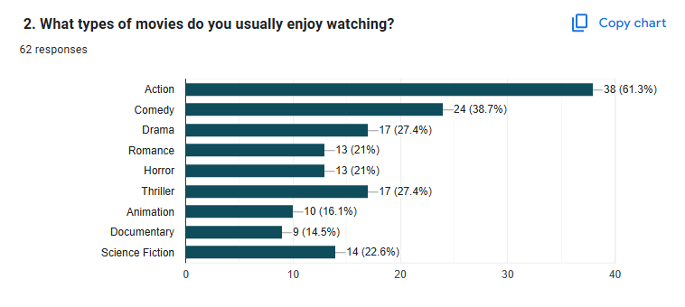
This chart shows the movie genres people enjoy most. Action is the top favorite, chosen by 61.3% of participants, followed by Comedy (38.7%), Drama and Thriller (27.4%), and Science Fiction (22.6%). Romance and Horror were each selected by 21%, while Animation and Documentary were less popular. From my point of view, this tells me that my recommendation system should focus more on suggesting Action and Comedy films since they appeal to the largest group. At the same time, it should still include a mix of genres to fit users who enjoy variety. This kind of genre-based insight helps the system personalize better suggestions that match different tastes.

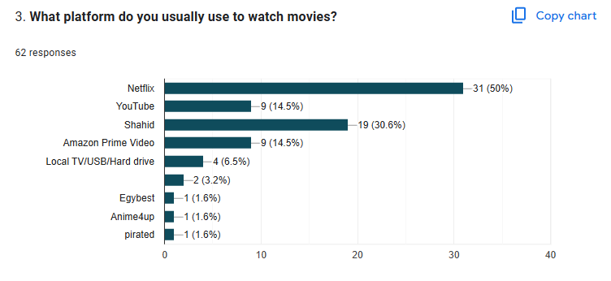

This chart shows that half of the participants (50%) mostly use Netflix to watch movies, followed by 30.6% who use Shahid. Platforms like YouTube and Amazon Prime Video are used by 14.5% each, while other options like TV, USB, or smaller websites are much less common. From my point of view, this means my recommendation system should aim to behave like popular platforms such as Netflix or Shahid, where users already expect smart and personalized suggestions. It also shows that the system must support content that feels familiar to users who are used to these services.

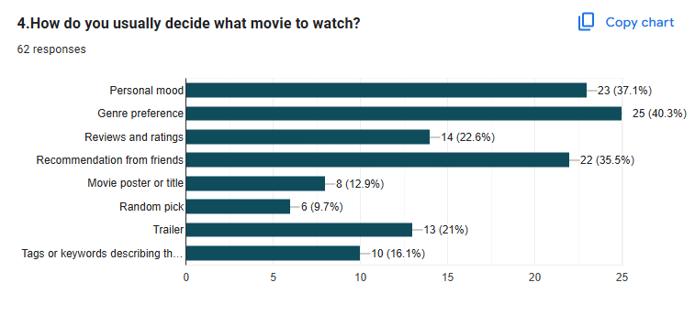
This chart shows that most people decide what movie to watch based on genre (40.3%) and their personal mood (37.1%). A large group also listens to friend recommendations (35.5%), while fewer choose based on trailers (21%), reviews (22.6%), or tags and keywords (16.1%). From my point of view, this confirms that including genre and mood in the recommendation system is very important. It also shows that using tags and allowing users to filter based on how they feel could make the system more helpful and user-friendly.

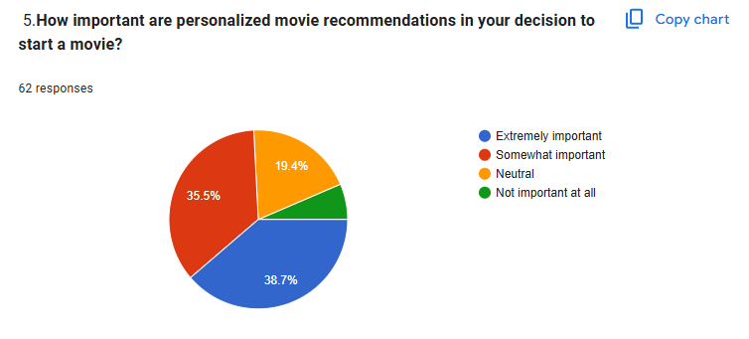

This chart shows that 38.7% of people think personalized movie recommendations are extremely important, and 35.5% think they are somewhat important. That means over 70% of users care about getting suggestions that match their taste. Only a small group felt neutral or not interested. From my point of view, this proves how valuable a smart AI recommendation system can be. If it’s well-designed and personal, it can really help users choose faster and enjoy movies more.

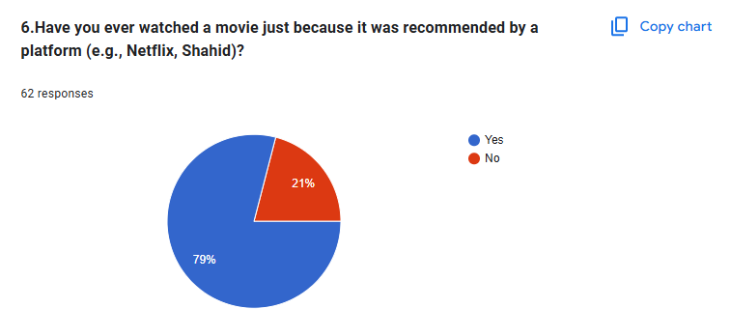

This chart shows that 79% of people have watched a movie just because a platform recommended it, while only 21% said no. This tells me that recommendations really do influence what people choose to watch. From my point of view, this supports the idea that building a smart AI-based recommendation system is useful it can actually guide users and increase the chances they’ll watch something new based on suggestions.

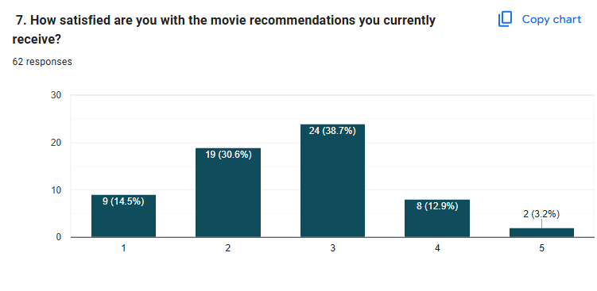
This chart shows that most people rate their satisfaction with movie recommendations around the middle, with 38.7% choosing 3 and 30.6% choosing 2. Only a small number gave the highest score of 5 (3.2%). This means that while recommendations are somewhat useful, they still don’t fully match what users really want. From my point of view, this highlights the need for improvement. My project aims to build a smarter recommendation system that better understands users and gives more accurate, satisfying suggestions.

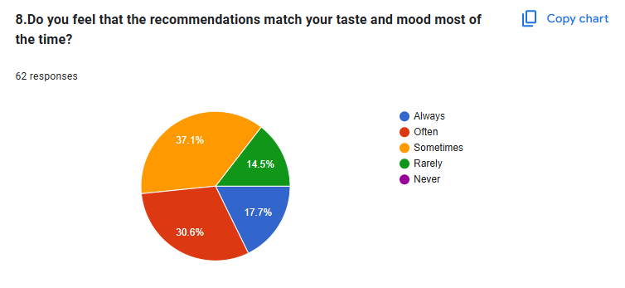

This chart shows that 37.1% of users feel that movie recommendations only sometimes match their taste and mood, while 30.6% say it happens often, and just 17.7% say always. A smaller group (14.5%) rarely finds the suggestions accurate. This tells me that recommendation systems are not fully capturing people’s personal preferences and feelings. That’s why my project focuses on improving mood and context understanding to give smarter and more personal movie recommendations.
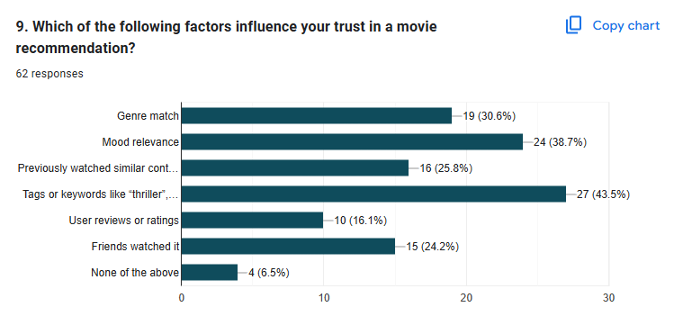

This chart shows that the top factors that make people trust a movie recommendation are tags or keywords (43.5%), mood relevance (38.7%), and genre match (30.6%). Fewer users rely on things like previous watches, friend activity, or reviews. From my point of view, this clearly supports using tags and mood-related data in my AI model. If I design the system to recommend based on how a movie feels and its descriptive tags, people will trust it more and likely use it more.

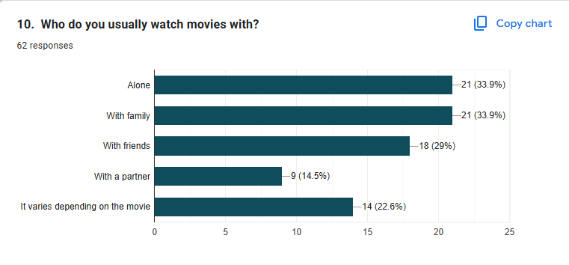

This chart shows that people mostly watch movies either alone (33.9%) or with family (33.9%), while others enjoy watching with friends (29%) or depending on the movie (22.6%). Only a smaller group watches with a partner (14.5%). From my point of view, this suggests that recommendation systems should consider both solo and group viewing preferences. My project can improve by recommending movies that match different types of groups, making it more helpful for real-life watching situations.

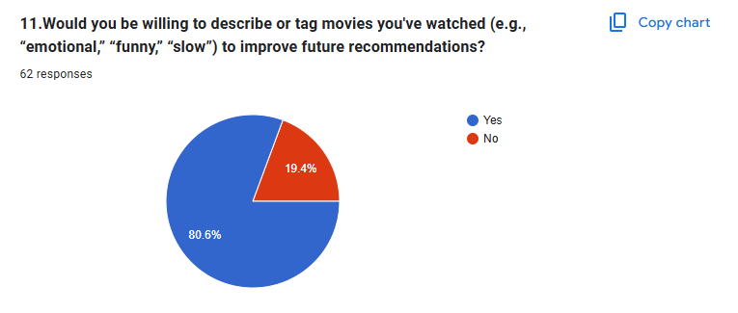

This chart shows that most people (80.6%) are willing to describe or tag the movies they've watched using words like "emotional," "funny," or "slow" to help improve future recommendations. Only 19.4% said no. From my point of view, this is a strong sign that users are open to helping the system by adding useful tags. This fits perfectly with my project idea, which is based on tags, because it means the AI model can use user-generated tags to make smarter and more personalized recommendations.

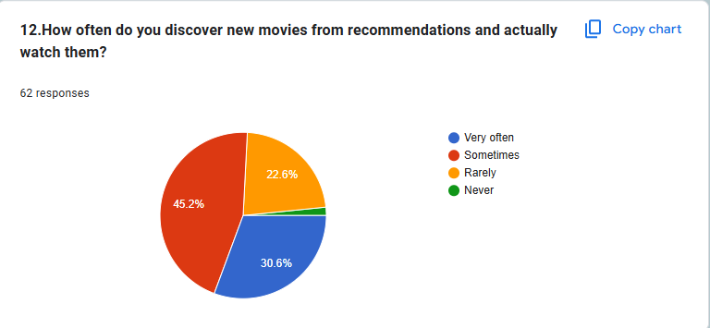

This chart shows that 45.2% of people sometimes watch new movies based on recommendations, while 30.6% do so very often. A smaller group, 22.6%, rarely follow recommendations, and only 1 person (1.6%) never does. From my point of view, this confirms that recommendations play a big role in helping people discover movies. This supports my AI project idea, since it means a good recommendation system especially one based on tags can actually influence what users choose to watch.

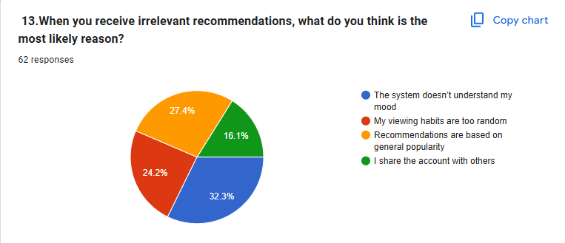

This chart shows that most people (32.3%) think they get bad movie recommendations because the system doesn’t understand their mood. Others say it's because suggestions are too random (24.2%) or based only on what’s popular (27.4%). A smaller group (16.1%) said the issue might be that they share their account with others. From my view, this proves why using tags that match mood or movie vibe is important. My project focuses on making the system smarter by using tags, which can help avoid these kinds of problems and make the recommendations feel more personal.

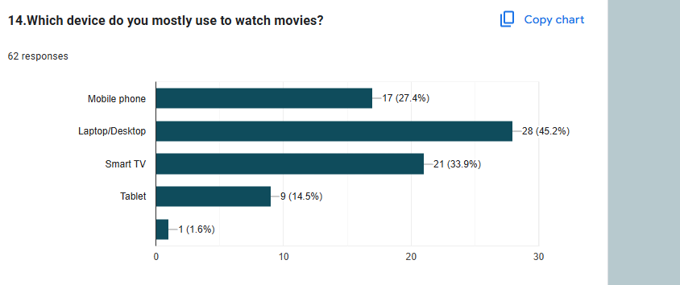

This chart shows that most people (45.2%) watch movies on a laptop or desktop, followed by 33.9% who prefer using a smart TV. Some use their mobile phones (27.4%), while only a few watch on tablets (14.5%) or other devices. From my point of view, this means recommendation systems should be easy to use on both computers and big screens. That’s why I focused on making my system user-friendly and accessible across different devices, especially laptops and smart TVs where most users are active.

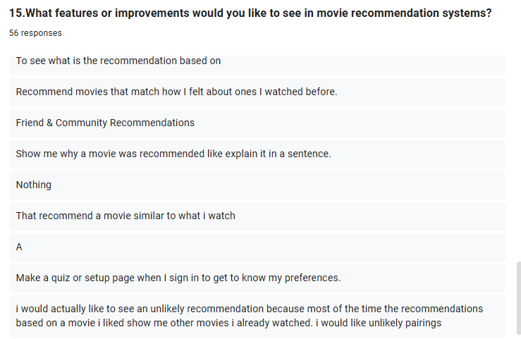

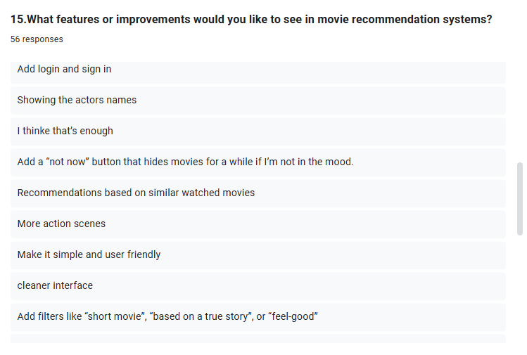

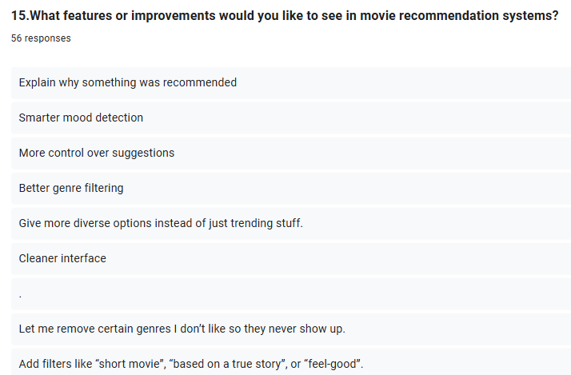
Based on the responses to question 15, users expressed a strong desire for movie recommendation systems to be more transparent, personalized, and flexible. Many participants wanted to understand why a movie was recommended, suggesting a need for explanations or short notes that clarify the connection between the recommendation and their preferences. A major recurring theme was mood-based suggestions—users want the system to detect or ask about their current mood before suggesting anything. Others highlighted the need for filtering tools, such as removing genres they dislike, adding filters like “based on a true story,” or choosing movies by specific attributes like length or rating.
From my point of view, these suggestions show that users want more control over the system. They don’t just want random or popular picks—they want recommendations that match their current mood, viewing history, or even their emotions from past movies. Some also asked for weekly updated top lists, a simpler interface, and even community or friend-based recommendations. One interesting suggestion was to receive “unlikely” recommendations that still align with past interests but explore new directions.
This feedback clearly supports the idea of building a context-based AI model that doesn’t rely only on categories, but also on semantic similarity and user input, making it smarter and more human-like in understanding what users really want to watch.

Data Usage:
The collected data is used to understand how people currently interact with movie recommendation systems and what they expect from them. It helps in identifying weaknesses in existing platforms and provides insights for building an AI-powered movie recommendation model that focuses on personalization, mood detection, and better content matching. The survey results directly support improving the system’s ability to suggest movies that are more relevant and engaging for users.
Analysis Techniques:
Basic statistical analysis was used to explore patterns in movie-watching habits, preferences, and trust in recommendations. The data also helps group users based on behavior, like how often they watch movies or what features they value in a recommendation system. This makes it easier to understand what kind of improvements would make the system smarter and more useful for different types of viewers.

- Data-Driven Insights for Movie Tags Dataset

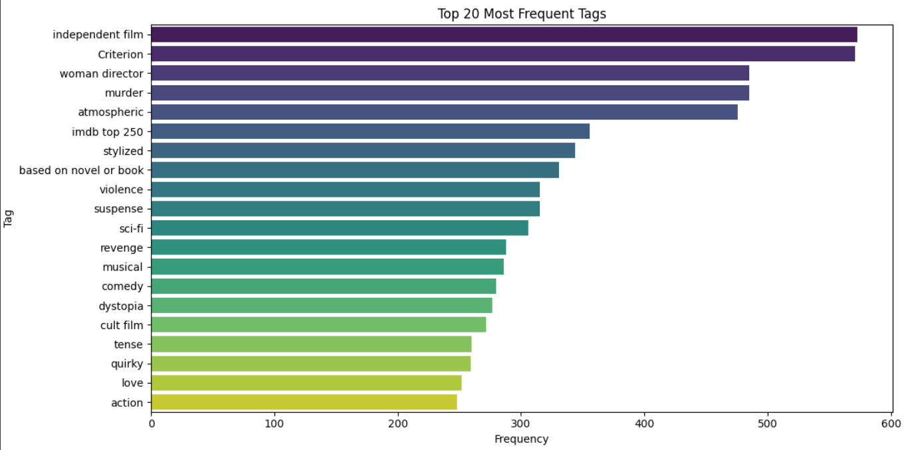
The bar chart gives us an image of the 20 most prevalent tags in the MovieLens tags.csv dataset. Tags such as “independent film,” “Criterion,” “woman director,” and “murder” dominate the listings and thus suggest a great deal of artistic, thematic, stylistic flesh, and blood in contexts behind user perceptions of films.

Tags distinguish themselves from structured metadata such as genres, providing very subjective views into how someone perceives a film — including elements such as feel ("atmospheric", "suspense"), story detail ("revenge", "based on novel or book"), and mood ("tense", "quirky", "love"). Such subjectivity is crucial to develop a context-aware movie recommendation system since these tags give insights into emotional and situational context that traditional genre labels often miss.

The frequency for more finely nuanced tags such as "dystopia," "cult film," and "IMDB top 250" goes to show that the users value distinctness, critical evaluation, and niche classifications. This backs the conception that recommendation systems should be working not just in matching genres but also in matching individual's viewing intentions, and its context-relevant mood.

When these commonly used tags are introduced as contextual features, the engine can then take recommendations to a considerable degree beyond the bounding box of classical collaborative filtering towards contextual, experience-based recommendations.

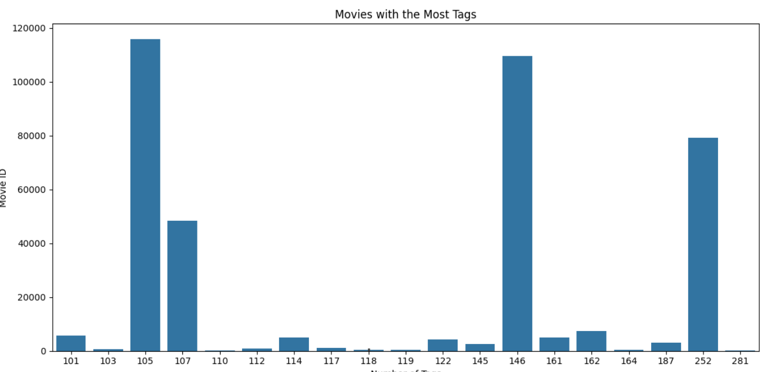
This chart shows which movies have the highest number of tags from users. Tags are like words or phrases that people use to describe a movie. For example, someone might tag a movie as "suspenseful" or "funny."
From the chart, you can see that a few movies got a massive amount of tags compared to others. That probably means those movies are super popular or talked about a lot. It also tells us that these movies give strong feelings or vibes, which makes people want to describe them more.
For my recommendation system, this is really helpful. If a movie has a lot of tags, that means it has more detailed descriptions, which makes it easier for the AI to understand its context and suggest it to the right person. More tags = better understanding = smarter recommendations.
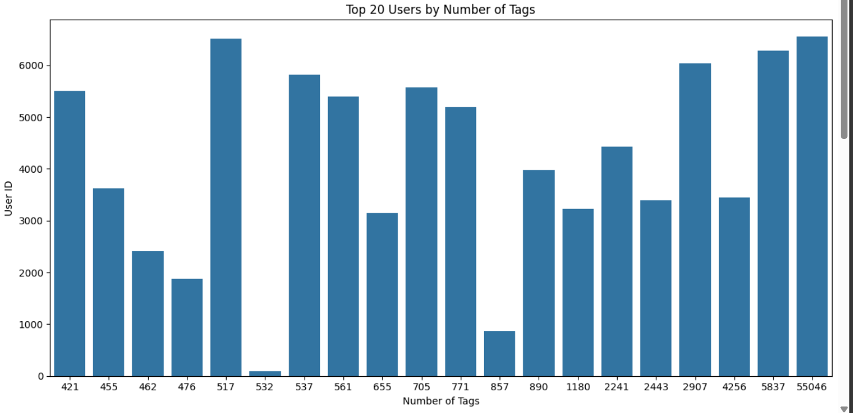
This chart shows the top 20 users who added the most tags to movies. Each bar is a user, and the taller the bar, the more tags they added.
Some users added a crazy number of tags — like over 6,000. That means they were super active and probably love sharing their opinions on movies. On the other hand, some users added way fewer tags.
This kind of data helps in my project because users who add a lot of tags give more info about movies. That helps the system learn what people think about different types of movies and gives better suggestions to others.

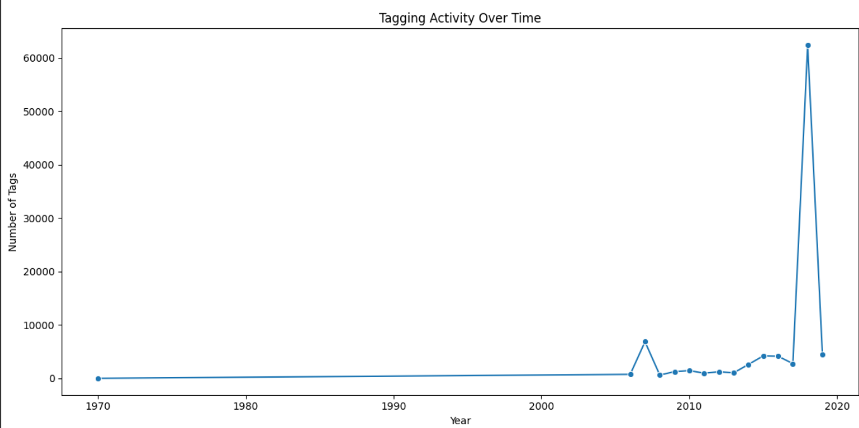

This chart shows how often people were tagging movies over the years.
As you can see, not many tags were added before 2006. Then around 2008, tagging started happening more often. But the biggest jump happened around 2018, where the number of tags went crazy high. After that, the numbers dropped again.
This tells me that at some point, a lot more people got involved in tagging movies, maybe because of new platforms or tools. For my recommendation system, this helps because more recent movies probably have better tag data, which means the system can understand them more clearly and give smarter suggestions.

- Implementation Summary
The implementation of the context-based movie recommendation system focused on building an AI engine that uses semantic similarity between movie tags to suggest films with similar context. The core idea was to recommend movies based on how users describe or tag them—such as "thrilling," "romantic," or "true story"—rather than just fixed genres or ratings.
The system was developed using Python in Google Colab. Main libraries included Pandas (for data processing), Scikit-learn (for TF-IDF vectorization and cosine similarity), and Matplotlib (for data visualization). The dataset used was the MovieLens tags.csv file, which includes movie IDs, user IDs, tags, and timestamps.
In the data preparation stage, only the relevant columns were selected: movieId and tag. Duplicate or missing values were removed, and all tags were converted to lowercase and cleaned. Tags were then grouped by movieId and combined into a single string per movie to represent each film’s context.
Next, TF-IDF (Term Frequency–Inverse Document Frequency) was used to transform these tags into numerical vectors. This method gives more importance to rare but meaningful tags. After generating the vectors, cosine similarity was applied to calculate how closely related the movies are based on their tag vectors.
Finally, the recommendation engine allows the user to input a movie ID and returns the top 10 most contextually similar movies. The output includes the movie ID, its tag context, and similarity scores. This approach allows recommendations that feel more human—matching mood, themes, or story elements instead of simple category overlap.
- Output and Interpretation
The output of this system is a list of movies that are most similar in meaning and tag description to the input movie. For example, if the input movie has tags like “thriller,” “twist ending,” or “murder,” the system will suggest other movies with similar tag patterns.
The recommendation results include:
- Movie ID
- Combined Tags
- Similarity Score
Because the model uses TF-IDF, it can capture deep semantic similarities, not just shared words. For example, two different tag sets like “war drama” and “based on a true story” might be matched because of their thematic closeness.
These outputs are displayed as tables in the notebook and are easy to interpret. They provide useful and intelligent suggestions that mimic how people associate similar movies based on vibe, topic, or mood not just genre.
- Analysis of Effectiveness
This recommendation model turned out to be practical and intelligent, especially because it doesn’t rely on user ratings or viewing history. Its main strength is semantic matching understanding movies based on how people describe them with tags.
By using TF-IDF and cosine similarity, the system can find movies with similar feel or purpose even if the exact words are different. For example, movies tagged “space mission” and “interstellar travel” might be matched because of their thematic closeness.
Another benefit is transparency users and developers can understand why a movie was suggested, based on visible tags and similarity scores. The model is also lightweight and fast, which makes it easy to use even with limited resources.
However, the model has limitations. Its success depends on the quality and quantity of tags. Movies with few or generic tags might not get accurate recommendations. Also, since the system doesn’t use user-specific behavior, it can’t fully personalize recommendations based on past watch history or individual preferences.
Still, the model serves as a strong base for context-aware movie recommendations and can be extended in the future with collaborative or hybrid methods.
- Comparison and Justification
Earlier versions of the project explored basic classification approaches, but these did not match the goal of recommending movies. The shift to a context-based model using TF-IDF and cosine similarity proved more aligned with the research aim offering smart and human-like suggestions based on the emotional and descriptive content of tags.
Unlike traditional systems that rely on rating prediction or fixed genres, this model mimics real-world platforms like Netflix, where content meaning and feel are more important than just technical categories. It also works without labeled output or user profiles, making it useful even for new users or lesser-known films.
- How the Results Meet the Research Question and Objectives
Research Question: "How can context-aware, AI-powered algorithms improve the accuracy and personalization of movie recommendations?"
Research Objectives:
- To understand user preferences and behavior toward movie recommendations.
- To identifykeyfeatures(e.g., tags, mood, genre) that affect trust and satisfaction.
- To build acontent-based recommendation system that improves personalization using semantic context.
- Connecting Results to Research Question and Objectives

- Understanding Consumer Preferences and Behaviors: The survey showed that users care about genres, mood, and movie context. They often choose what to watch based on feelings or tag-related cues. This confirms the need for a tag-driven system.
- Key Factors Influencing Trust and Satisfaction: Responses highlighted the need for transparency (users want to know why something was recommended), and the importance of mood and vibe. This matches the model's ability to recommend based on tag meaning rather than fixed labels.
- Enhancing Personalization: The tag-based approach gives the system the ability to personalize without needing past user data. By understanding movie context through tags, it can suggest relevant content to both new and regular users.
- Merits and Limits of the Analysis
Merits:
- Combines real user feedback with meaningful dataset insights.
- Uses semantic vectorization (TF-IDF + cosine similarity) for deeper recommendations.
- Aligns with how platforms like Netflix and Shahid offer suggestions.
- Works well even when ratings or viewing history are missing.
Limits:
- It depends heavily on the quality and quantity of tags.
- Doesn’t use personal viewing behavior, which limits full personalization.
- Based on a single dataset (MovieLens), so may not reflect global platform behavior.
- Captures one point in time new trends may require updated tagging and retraining.

Conclusion and Recommendations
Aim of the Study:
The main aim of this study was to build a context-aware movie recommendation system using tag-based data. The system was developed to suggest movies based on their semantic similarity by analyzing tags provided by users in the MovieLens dataset. The goal was to improve the relevance of recommendations by focusing on content-based filtering using techniques such as TF-IDF vectorization and cosine similarity.

Summary of Findings:
This study successfully developed a recommendation engine that compares movies based on their descriptive tags. It used text-based techniques like TF-IDF and cosine similarity to measure how closely related different movies are in meaning. The survey results showed that users care about personalized suggestions and are influenced by movie tags, moods, and context when deciding what to watch. The system was tested on a sample of the dataset to reduce memory usage and still returned accurate and meaningful recommendations. Movies with similar emotional or thematic tags were grouped correctly, showing that the model understood the content well. The recommendation results were presented in a clean, table-based format to improve readability and interpretation.

- Load and Clean Dataset
This step ensures that the dataset is clean and only includes movies with actual tag values. Removing null entries helps prevent errors during text processing and improves the accuracy of the recommendation engine.
- Use a Sample of Top-Tagged Movies to Reduce Memory Usage
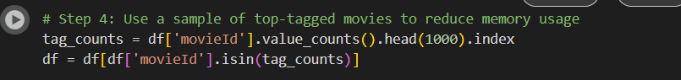
This step reduces memory usage and processing time by narrowing the dataset to the most relevant and well-tagged movies. It helps the recommendation engine run more efficiently while still working with a meaningful sample of data.
- Group Tags by Movie
This step creates a single row per movie where all tags are combined into one string. This format is more convenient for text processing tasks like generating embeddings or computing similarities in the recommendation engine.

The code implements a context-based movie recommendation system using the MovieLens tags.csv dataset. It works by analyzing the tags people have given to movies, which are short descriptions or keywords that express how they felt or thought about a movie (like “funny,” “thrilling,” or “Pixar”).

This similarity matrix lets the system find which movies are most alike based on their tag descriptions. These similarity scores are later used to recommend movies that are contextually similar.
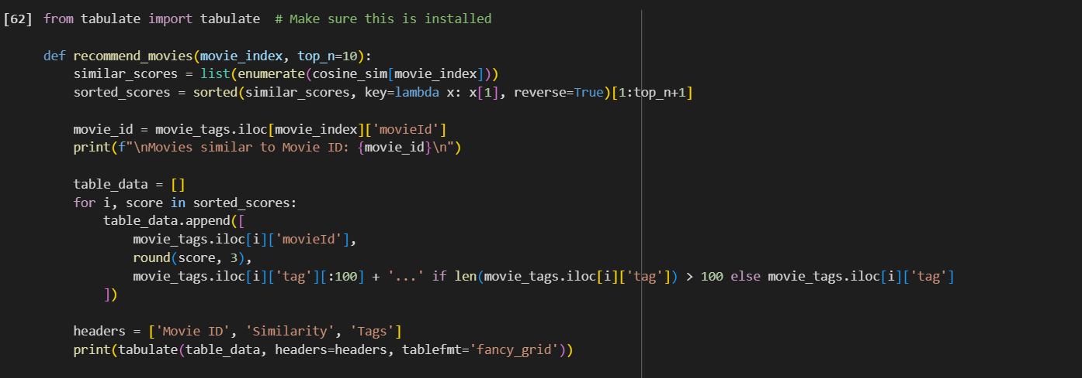
The function takes a movie index and prints the top N most similar movies based on their cosine similarity score using the TF-IDF vector.
It is helpful because:
The original recommendations were just printed in plain lines.
This version enhances readability with a structured, grid-style table format—especially helpful when displaying multiple results with long tags.
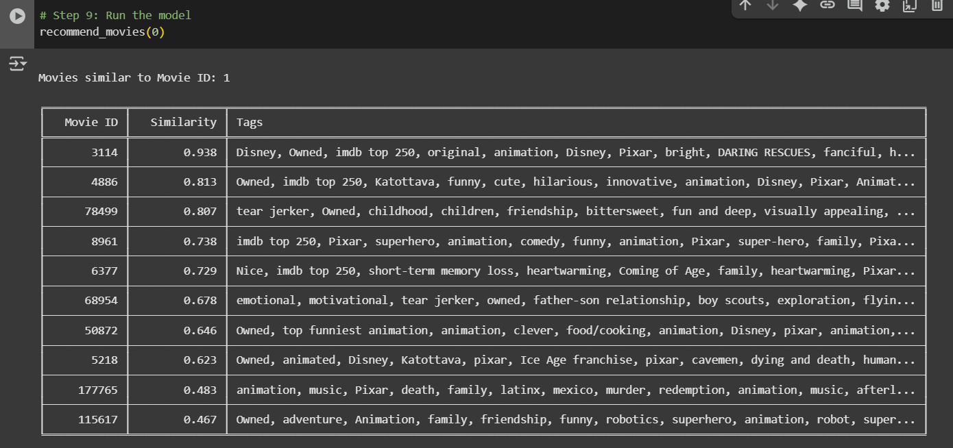
This screenshot shows the final movie recommendations generated by the context-based recommendation engine. Given a movie ID, the system identifies similar movies by applying cosine similarity to TF-IDF vectors built from user-assigned tags. As shown in the table, the recommended movies share similar thematic tags, such as genre, mood, and animation style, with the input movie. This demonstrates that the engine successfully captures contextual meaning and can suggest relevant alternatives based on tag-driven semantic similarity.

Recommendation

- Enhance Contextual Tag Usage
The system should continue leveraging tags (e.g., emotional, funny, suspense) as a core feature. These tags help the recommendation engine understand the deeper context and themes of each movie, going beyond basic metadata like genre or rating. This results in more meaningful and relevant suggestions for users.

- Integrate Mood Detection
Incorporating mood-based inputs (either by asking the user or through mood-detection tools) can further tailor recommendations. Many users prefer movies that suit their emotional state, and this feature ensures the system aligns with their current mood, increasing satisfaction and engagement.

- Allow User Tagging and Feedback
Letting users add their own descriptive tags or give feedback on recommendations (e.g., "too serious" or "not funny") can improve the system’s learning over time. This interaction helps the AI model refine its understanding of user preferences, leading to more personalized results.

- Combine with Collaborative Filtering
While the current system is content-based (using TF-IDF and cosine similarity), integrating collaborative filtering (which relies on user behavior and similarities between users) can further improve recommendations. This hybrid approach balances similarity with popularity and increases diversity.

- Maintain Efficiency with Top-Tagged Sample
Using the top 1000 most-tagged movies is a smart way to reduce memory usage while keeping recommendations relevant. This approach ensures the system runs faster without compromising the quality of its suggestions, which is ideal for real-time or large-scale applications.

- Add Advanced Filtering Options
Giving users the option to filter recommendations by additional criteria (like length, language, or “based on a true story”) allows for more control. It also helps users quickly find movies that meet their specific viewing needs or limitations.

Future Work

- Integrate User Profiles and Viewing History
Currently, the system focuses only on content-based recommendations using tags. Future development can involve collecting and analyzing user viewing history to create personalized profiles. This will allow the system to combine what the user liked before with the contextual meaning of new movies for better recommendations.

- Use Deep Learning for Semantic Understanding
Instead of just using TF-IDF, future work can explore advanced natural language processing models like BERT or Sentence Transformers. These models can better understand the meaning behind user tags and movie descriptions, making the system more accurate in matching movie context and emotions.

- Develop a Real-Time Web Application
A user-friendly web interface or mobile app can be created to let users interact with the recommendation engine in real time. This would allow users to search, filter, and receive movie suggestions instantly based on selected moods, genres, or custom tags.

- Expand Dataset for Better Coverage
The current dataset is limited to tags from the MovieLens data. Future work can involve combining other datasets (like movie summaries, user reviews, or IMDb keywords) to increase the system’s knowledge base and improve the quality and variety of recommendations.

- Implement Multi-Language Support
To make the system more inclusive, it can be improved to support non-English movies and tags. This would allow users from different regions and language backgrounds to receive meaningful recommendations, expanding the system’s reach.

- Evaluate with Real User Testing
Future work should include testing the system with actual users in real-life scenarios. Their feedback can help evaluate the recommendation quality, usability, and overall satisfaction, leading to more user-centered improvements.

Reflections
This project has been a valuable learning experience that helped me understand the practical side of artificial intelligence, especially in the area of context-based recommendation systems. At the beginning, I had very little background in AI or data science, so I found it difficult to choose a topic and understand the datasets. Through continuous work, feedback from my instructor, and trial-and-error during model implementation, I gradually learned how to work with real datasets, clean data, and apply algorithms like TF-IDF and cosine similarity.

One of the most important lessons I learned was how to connect technical tools with real user needs. Designing the survey and analyzing the responses helped me realize that AI should not just be smart, it should also make sense to normal users. This changed how I looked at recommendation systems. Instead of just showing similar items, I started to focus on how the system can make decisions that feel meaningful to users.

Technically, I became more confident using Python, Google Colab, and libraries like Scikit-learn and Pandas. I also learned how to fix errors and manage memory issues when working with large data. There were times when the model crashed or the results didn’t look right, but these challenges helped me understand the importance of data size, preprocessing, and code structure.

Personally, I developed more patience and problem-solving skills. I realized that research is not about having everything perfect from the start, but about improving step-by-step. I also learned the value of instructor feedback and peer examples, which helped me revise and improve my work.

In the end, this project gave me confidence to work on real AI projects in the future. I am now more aware of how data, algorithms, and user experience come together to build intelligent systems that can make a real impact.
  - Selected Research Methodology
The research process in this study followed a structured and flexible approach that supported the successful creation of an AI-based movie recommendation system using real Python code. At the start, the goal was to use machine learning to predict movie relevance using simpler models. But after academic feedback and deeper exploration, the direction shifted toward a context-based recommendation engine that uses natural language processing (NLP) and semantic similarity to improve recommendations.

This change allowed the system to become more meaningful and realistic, matching how real-world platforms like Netflix or Shahid work. The workflow included reading and cleaning the MovieLens tags dataset, selecting relevant textual features, using TF-IDF to convert tags into numerical form, and applying cosine similarity to recommend movies based on semantic similarity. This made the model focus on the meaning behind the movie tags rather than just matching labels.

One important step in the process was using real Python implementation instead of drag-and-drop tools. Moving to full code development gave more control, flexibility, and a deeper understanding of how AI models function. This also made the solution technically stronger and more adaptable for future improvements.

While the final system worked well and gave accurate tag-based recommendations, the process involved many adjustments, such as resizing the dataset to avoid memory errors in Google Colab, and finding the best way to display the recommendations in a table format. These challenges helped improve the final model and highlighted the value of flexibility and iterative development in AI research.

Merits of the Selected Method
- Context-Aware Recommendation: The method focuses on tag-based context rather than static genre labels or demographics. Using TF-IDF and cosine similarity lets the system recommend movies based on how users describe them, making the results feel more natural and human-like.

- Explainable Output: Each recommendation is based on measurable similarity between movie tags, which makes the results easy to explain. This improves user trust and helps researchers understand how the system works internally.

- Lightweight and Scalable: The use of basic NLP tools like TF-IDF makes the system simple to run on limited resources. This is helpful for small projects or early-stage deployments where heavy models like neural networks are not practical.

- Hands-On Learning: Implementing the system with Python allowed for real-world coding experience and practical understanding of how AI recommendation systems operate, moving beyond theory into actual application.

Limitations Encountered
- Tag Quality Issues: The model relies heavily on the quality of movie tags. If some movies have few or unclear tags, the recommendations become less accurate.

- Lack of User History: The system does not use personal viewing history, ratings, or preferences. As a result, it can’t provide fully personalized results for individual users.

- Static Design: The current model does not learn over time or adapt based on user feedback. It gives the same recommendations unless the dataset is manually updated or retrained.

- No Real-Time Integration: The system works well in testing but hasn’t been connected to a live platform. That means it doesn’t respond to new movies or live user behavior yet.

- Basic NLP Techniques: TF-IDF is effective for general similarity, but it misses deeper context or relationships between phrases. More advanced techniques like word embeddings or BERT could capture this better.

Potential Pitfalls in the Selected Method
- Over-Reliance on Tags: If a movie has few or repetitive tags, the system may not find good matches. This makes the recommendation quality highly dependent on how well the tags represent the movie.

- No Dynamic Learning: Since the model doesn’t update itself, it won’t improve over time or adjust based on user interactions. This may reduce long-term effectiveness.

- Computational Load in Large Datasets: As more movies and tags are added, cosine similarity becomes heavier to compute. This can slow down the system or require optimization techniques.

- Surface-Level Matching: TF-IDF looks at word frequency, not meaning. That means it may miss the deeper message of a movie or why someone liked it, leading to less relevant results in some cases.

- Privacy and Ethics: Although this system doesn’t use personal data, future versions that include personalization must protect user privacy and avoid bias or unfair recommendations.
  - Alternative Research Methodologies
In this study, the chosen methodology centered on a context-based recommendation system using tag similarity through TF-IDF and cosine similarity. While this approach proved effective in generating accurate and explainable movie suggestions, alternative research methodologies could have also been explored depending on the project scope and goals.

Alternative Methodologies Considered
- Collaborative Filtering
This approach uses user behavior, such as ratings and watch history, to recommend items. Although effective in personalization, it requires large amounts of user interaction data. Since our project did not include personal user logs, this method wasn’t feasible but could be useful in future iterations.

- Deep Learning-Based Models (e.g., Neural Networks, BERT)
Advanced NLP techniques like BERT could have provided a deeper semantic understanding of tags and plot descriptions. These models can capture more subtle meanings but are computationally intensive and require larger datasets and training time. While not used due to technical limitations in Google Colab, this method would be powerful for future work involving larger systems.

- Hybrid Recommendation Systems
These combine both content-based and collaborative filtering. Hybrid systems offer better balance by using both user preferences and item content. Though more complex to implement, this approach could provide more personalized and accurate results compared to content-only models.

Lessons Learned in View of Outcomes
- Simplicity Can Be Powerful
Using TF-IDF and cosine similarity allowed for building a lightweight yet effective model. Even without user data, meaningful recommendations were achieved by focusing on descriptive tags, showing that context-based filtering works well in low-resource settings.

- Textual Data Quality Matters
The results of the recommendation model heavily relied on the quality and consistency of the movie tags. A key takeaway is that for context-based systems, clean, meaningful, and diverse textual data is crucial.

- Balancing Complexity and Feasibility
While deep learning could have improved results, it would have introduced more complexity than was needed for the current academic scope. The lesson learned was that it's important to match the model complexity to the available data and computing environment.

- Flexibility is Critical
Adapting from an original idea (such as a classification model) to a context-aware recommendation system showed the importance of flexibility. Being open to changes based on feedback and performance is key to producing a more effective and practical solution.
  - Recommended Actions and Future Considerations
Reflecting on the research process and outcomes, several key recommendations and future considerations can be drawn to enhance the practicality, precision, and adaptability of context-based AI recommendation systems in movie platforms.
One of the most crucial actions is the continued improvement of tag preprocessing and contextual feature design. In a system that relies on user-generated tags to determine similarity between movies, the consistency and quality of those tags directly impact the effectiveness of the recommendations. Future development should focus on refining tag cleaning techniques, applying methods such as stop-word removal, stemming, and normalization. Additionally, grouping similar tags or detecting tag clusters (e.g., emotion tags, genre tags, mood tags) can help the system make better contextual distinctions between different movies.
Another recommended action is to develop a real-time recommendation layer that allows users to interact with the system directly. While the current implementation is static and runs within a notebook environment, deploying it in a web-based or application interface would enable real-time recommendations. This would involve integrating a simple user interface, allowing input of a movie ID or title, and returning a list of contextually similar movies instantly. Adding live interaction tracking could also help in updating recommendations over time.
Improving the explainability of recommendations is another vital step. Although the current system uses TF-IDF and cosine similarity, which are relatively easy to interpret, future versions may use more advanced models like BERT or neural embeddings. In such cases, incorporating explainable AI (XAI) features would allow users to understand why a specific movie was suggested—whether due to shared tags, mood similarities, or viewing trends—ultimately building trust in the system’s outputs.
Moreover, expanding the model to handle multi-dimensional data would improve recommendation accuracy. This includes integrating other metadata such as user mood (collected via survey), movie genres, or platform preferences. A hybrid approach that combines content-based filtering (tags) with collaborative filtering (user ratings or watch history) can offer more personalized recommendations that evolve with the user’s behavior.
Lastly, ethical considerations and privacy protection should remain a focus as the system develops further. Even though this model does not currently use personal data, future improvements involving behavioral analysis or feedback loops must ensure data security and respect user anonymity. Techniques such as anonymized interaction logging or federated learning can support future learning while maintaining privacy.
By addressing these areas, future versions of the tag-based AI movie recommendation system can grow into smarter, more scalable, and user-aligned tools that meet modern viewer expectations and support decision-making on popular streaming platforms.

  - Recommended Methodology
Updated version of paper Methodology (flowchart, block diagram) with discussion.
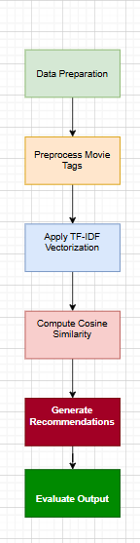

1. Data Preparation
This step involves loading the raw dataset (tags.csv) and cleaning it by removing null values in the tag column. Ensuring data completeness is essential because missing tags would weaken the input foundation for further analysis.

2. Preprocess Movie Tags
Tags belonging to each movieId are grouped and combined into a single string. This aggregation forms a unified textual representation of each movie’s contextual metadata, which is crucial for textual similarity calculations.

3. Apply TF-IDF Vectorization
Using TfidfVectorizer, each movie's tag string is transformed into a numerical vector. This step encodes the importance of each term across the corpus, enabling the model to distinguish between common and meaningful tags.

4. Compute Cosine Similarity
Cosine similarity is computed between TF-IDF vectors to measure how contextually similar two movies are. This mathematical comparison is at the core of the recommendation logic, ensuring that suggested movies are semantically relevant.

5. Generate Recommendations
Once similarity scores are computed, the top N most similar movies to a given one are selected and displayed. These recommendations are based on contextual alignment with the input movie’s tags.

6. Evaluate Output
The final phase involves examining the quality of the recommendations. It checks if the results logically align with expectations based on shared tags, and helps verify the system’s accuracy and usefulness.

References
[1] A. Melnikovas, “Adapting Research Onion Model for Futures Studies,” https: //www.semanticscholar.org/paper/Towards-an-Explicit-Research-Methodology-% 3A-Adapting-Melnikovas/dccf54a5a4312ceb2261e1989cda01f73989d735, 2018, [Online; accessed 10-Jan-2024].

